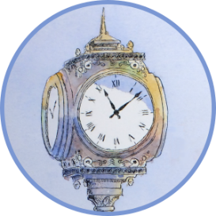
DRAW 01867 - Downtown Reading Art Walk
draw01867@gmail.com
facebook.com/DRAW01867
draw01867.org
“RENEWAL”
Entry Number: _________________________
Location: ______________________________
Assigned by Committee

Release of Liability Form: Print and bring filled out form to the Drop-Off
DROP-OFF ARTWORK: TBD. August ##, 2022, #:00 – #:00 PM.
Please contact us if you are unable to drop-off between these hours.
Artist Information
Last Name, First: Click here to enter text.

TEL: Click here to enter text.
Email: Click here to enter text.
Title of Work: Click here to enter text.
Title of Work: Click here to enter text.

Drop-off of Artwork
I understand the DRAW Committee assumes no responsibility for loss, damage or theft of artwork.
Signature of Entrant: _______________________________________________ Date: __________________
Print Name of Entrant: Click here to enter text.

Pick-up of Artwork
I have received the above entries in satisfactory condition.
Signature of Entrant: _____________________________________________ Date: __________________

Cut along line and affix to the back of artwork O
Name: Click here to enter text. O Name: Click here to enter text.
TEL: Click here to enter text. O TEL: Click here to enter text.
Email: Click here to enter text. O Email: Click here to enter text.
Artwork Title: Click here to enter text. O Artwork Title: Click here to enter text.

